
DISTRICT PLATFORMS
[Document subtitle]

May 20, 2020
ASAP CALICUT

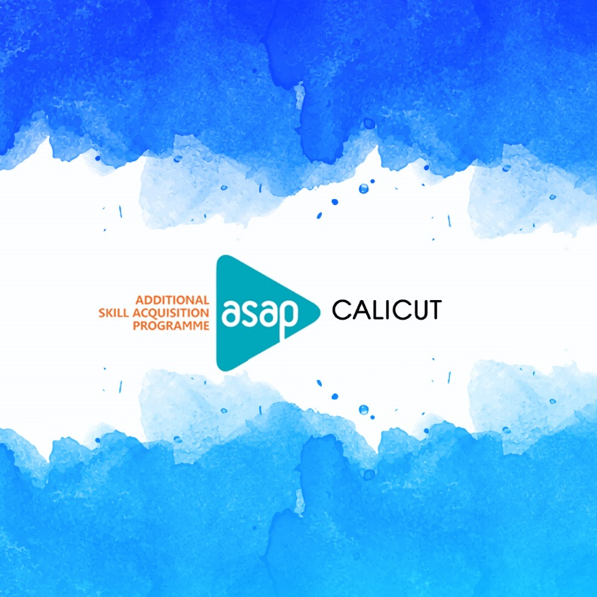

Lockdown Diaries

To make efficient use of the lockdown period, ASAP Calicut launched a Creative platform. The creative event was named ‘Lockdown Diaries'.

Lockdown Diaries
Events were conducted through the Facebook page of the district to bring out the hidden talents in the students. The event was named 'Lockdown Diaries' and the posters of the event were circulated among all SDC PM’S and SDE's thereby ensuring that the event information is passed to all institutions. Students from ASAP batches starting from 2012 were eligible to participate in the events.
Four events were conducted which started on 20th April 2020. The competitions which were conducted are: Mobile photography, capture a moment during the lockdown, Troll making competition, Letter writing competition, and down the memory lane.
MOBILE PHOTOGRAPHY
The competition was to capture a moment during the lockdown. 141 entries were received for the competition and two best photos were selected by a panel of judges.
TROLL MAKING COMPETITION
This competition was posted on 22nd April in which 49 students posted their trolls which was evaluated by a panel of judges and two best entries were selected, also the troll that got the maximum likes and comments was chosen for giving a special recognition.
A LETTER TO CORONA
A letter to Corona was a letter-writing competition which received 47 entries. The students wrote about the difficulties that they are facing and whatever they want to communicate with the virus. This was evaluated and two best entries were selected.
DOWN THE MEMORY LANE
This was the last competition held in this series. The students can send a voice clip about their favorite memory or the one that comes to their mind. Certain rules and regulations were set up like time duration were fixed as 120 minutes and the voice clip should be purely in English. 35 entries were received and the best two were selected.
The details of winners were announced on the official Facebook page and the winners will be given recognition after the lockdown.

Learni

